16th October 2009

Issued by:

Ambient Pressure Diving Ltd
UK
Tel: 01326 563834
Email: info@apdiving.com

Products: All APD rebreathers with Vision controllers:

It has been brought to our attention that when operating some hydraulic equipment underwater, there is a possibility of inadvertent, Vision handset, button operation and extra care must be taken to monitor the rebreather display at more frequent intervals.

Specifically, whilst assisting in the operation of a Jack hammer / road drill underwater, the percussion exhausts will have sufficient force, frequency and focus to press the buttons when within 2 feet (60cm) and when facing the percussion exhausts.

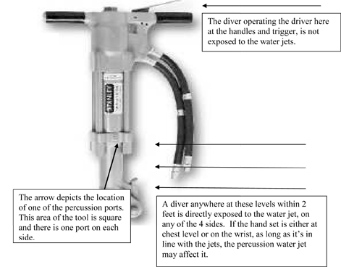

In tests, the button operation is random and this switching can cause a setpoint change or cause it to go in and out of OC mode and/or make any number of changes within the underwater menu including gas options, HUD brightness, LCD contrast, backlight, diluent gasses and bailout gasses. While either oxygen controller can be turned off and on, it is not possible to turn both oxygen controllers off simultaneously while deeper than 1.2m/4ft, providing there are two good batteries fitted.

We have been unable to reproduce the inadvertent button presses with normal diving applications. Tests include tap and fast water movement including moving handsets through water as fast as possible, diving in Rivers and tidal current, scootering, jump tests from various heights and various angles and we can state that inadvertent button pressing is highly unlikely. The fact is we didn‚Äôt get any inadvertent button presses in any of these tests.

Furthermore, this is not a problem for the diver holding the handles of the jack hammer, the problem exists for the diver assisting if he works lower down near the percussion exhausts.

Ambient Pressure Diving would like to take this opportunity to re-iterate to all rebreather divers the importance of looking at the PO2 displays regularly and draw your attention to the key waypoints during a dive where it is essential to monitor the PO2.

The following is extracted from the Inspiration user manual:

http://www.apdiving.com/en/wp-content/uploads/oxygen-danger-points-apdiving.pdf

